ESTIMATION OF BUSINESS EXPENSES

INTRODUCTION:

This paragraph introduces a report that delves into the realm of business expenses. The report aims to provide a visual exploration of the various expenditures incurred by different businesses. It focuses on showcasing the distribution of expenses, identifying key factors influencing costs, and shedding light on areas that could benefit from optimization or might be of concern. The visual representations in the report are designed to facilitate intuitive analysis, enabling a deeper understanding of spending patterns and their potential impact on business performance. The target audience for this report includes decision-makers, financial analysts, and stakeholders who can extract valuable insights into a business's financial health, spot areas of inefficiency or opportunity, and use this information to make informed decisions for resource optimization and growth. To carry out this analysis and present the data in an easily digestible format, the report utilized the Tableau tool, known for its capabilities in creating data visualizations, dashboards, and compelling data-driven stories

***PURPOSE:***

**To introduce and outline the focus and significance of a report that delves into business expenses. It highlights the objectives of the report, which include visualizing expenditure data, understanding expense distribution, identifying key cost drivers, and evaluating areas for potential improvement or concern. The paragraph also emphasizes the audience for the report, which consists of decision-makers, financial analysts, and stakeholders, and stresses the role of Tableau as the tool used to extract insights and present the data through visualizations, dashboards, and a compelling narrative.**

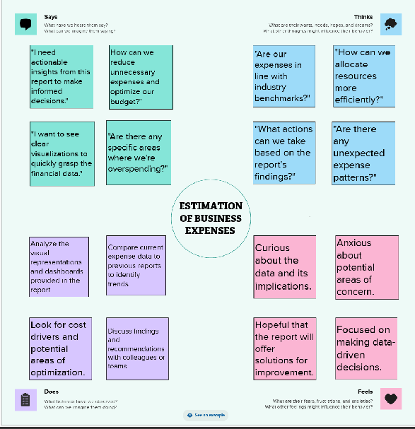**EMPATHY MAP**

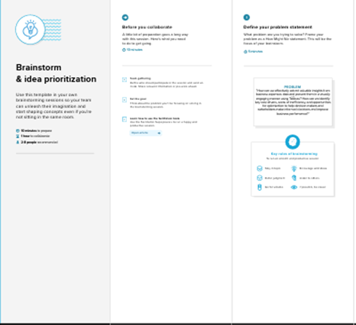 **IDEATION AND BRAIN STORMING:**

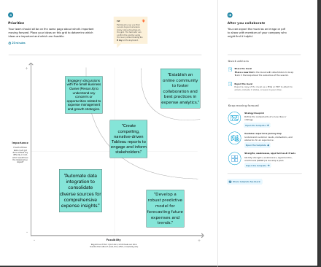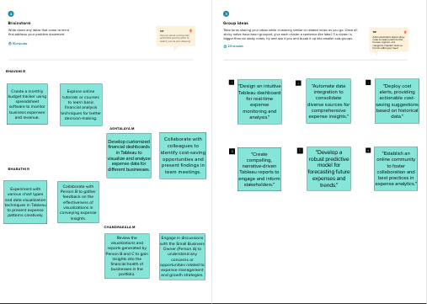**RESULT:**

**The paragraph describes a report that delves into the realm of business expenses, with a focus on visual exploration, cost distribution, identifying cost drivers, and areas for optimization or concern. It emphasizes that visual representations aid in intuitive analysis for a better understanding of expenditure patterns and their impact on business performance. This report is intended for decision-makers, financial analysts, and stakeholders to gain valuable insights into a business's financial health, identify areas of inefficiency or opportunity, and make informed decisions for resource optimization and growth. The tool employed for extracting insights and creating visualizations, dashboards, and stories is Tableau.**

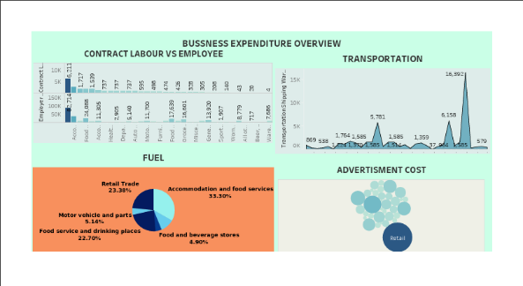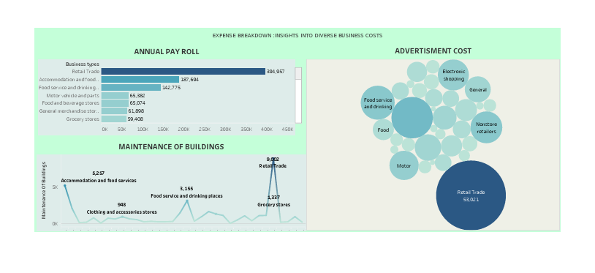

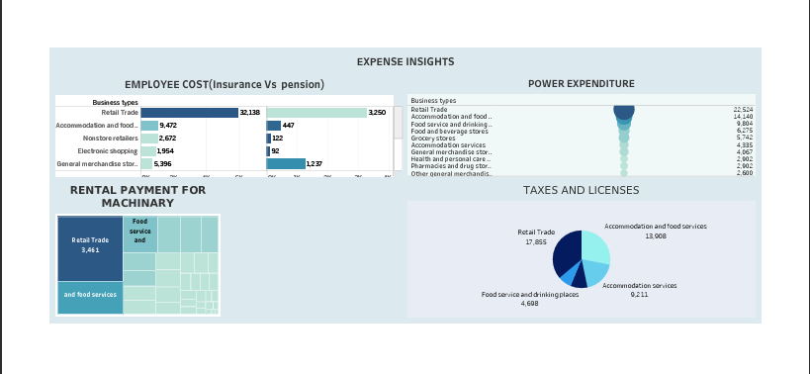 **DASHBOARD 1 DASHBOARD 2**

**DASHBOARD 3**

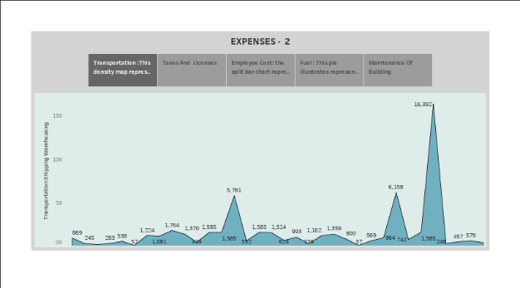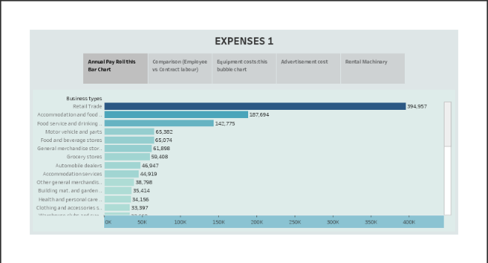

**STORY 1 STORY 2**

**ADVANTAGES OF BUSINESS EXPENSES:**

1. **Enhanced Data Visualization: Tableau excels at creating visually appealing and interactive data visualizations, making it easier to understand complex expense data. It allows users to explore data through various chart types, enhancing comprehension.**
2. **Distribution of Expenses: Tableau can effectively illustrate how expenses are distributed across different categories, enabling businesses to identify where their money is going and if it aligns with their objectives.**
3. **Identifying Key Cost Drivers: The tool helps in identifying the primary drivers behind various expenses. This is crucial for businesses looking to optimize their spending, as they can focus on areas that have the most significant impact.**
4. **Highlighting Areas for Optimization: Tableau can pinpoint areas that require cost reduction or optimization. This information can be invaluable for companies looking to enhance profitability.**

**DISADVANTAGE OF BUSINESS EXPENSES:**

1. **Cost of Tableau: One of the primary disadvantages of using Tableau is the cost associated with acquiring and maintaining the software. Tableau licenses can be expensive, and smaller businesses or individuals may find it challenging to justify the investment.**
2. **Learning Curve: Tableau is a powerful tool, but it also has a steep learning curve. Users, especially those who are new to data visualization and analytics, may need significant time and training to become proficient in using the software effectively.**
3. **Resource Intensive: Creating complex visualizations and dashboards in Tableau can be resource-intensive, both in terms of hardware requirements and the time it takes to process and render data. This may slow down older computers or require significant processing power.**

**APPLICATIONS:**

1. **Financial Analysis and Reporting: Businesses can use Tableau to create visual reports that provide a clear overview of their expenses, enabling finance teams to analyze and report on financial performance effectively.**
2. **Cost Optimization: By visualizing expenditure patterns, businesses can identify areas of inefficiency and take steps to optimize costs. This could include reducing unnecessary expenses or reallocating resources.**
3. **Stakeholder Communication: Visual representations in Tableau are valuable for communicating financial information to stakeholders, such as investors, shareholders, and board members. It helps in presenting complex data in an accessible way.**
4. **Decision Support: Decision-makers can use Tableau dashboards to make informed decisions about resource allocation and business growth strategies based on a visual understanding of expenses.**

**CONCLUSION:**

**The visual representations have proven instrumental in providing decision-makers, financial analysts, and stakeholders with a comprehensive and intuitive analysis of expenditure patterns. This deeper understanding, in turn, has significant implications for business performance. With this approach, it is now possible to identify both areas of inefficiency and untapped opportunities within the financial landscape of these businesses.**

**Ultimately, armed with these insights, businesses are better equipped to make informed decisions aimed at optimizing their resources and fostering growth. The use of Tableau has not only made data more accessible but has also transformed it into a powerful tool for driving strategic and financial decision-making.**

**FUTURE SCOPE:**

1. **Advanced Data Analytics: As technology advances, data analytics capabilities will continue to improve. Future versions of Tableau and other tools may incorporate more advanced predictive analytics, machine learning, and artificial intelligence algorithms. This would enable even more in-depth insights into expense patterns and the ability to forecast future expenditures with greater accuracy.**
2. **Real-time Reporting: Businesses are increasingly looking for real-time insights into their financial data. The future scope involves developing features that allow for live data integration and reporting, so decision-makers can monitor expenses and make immediate adjustments as needed.**
3. **Integration with IoT and Big Data: With the rise of the Internet of Things (IoT), businesses will generate vast amounts of data from various sources. Future tools like Tableau may need to adapt to handle and visualize this data, providing insights into how IoT-related expenses impact overall costs.**

**Top of Form**

**APPENDIX:**

**GITUP PUBLIC LINK - https://github.com/NM2023TMID10803/business-expenses_NM2023TMID10803.git**